**Sprint 1 - Endurance Design Document**

**March 28, 2024**

Table of Contents

1. Executive Summary 3

1.1 Project Overview 3

1.2 Purpose and Scope of this Specification 3

2. Product/Service Description 3

2.1 Product Context 3

2.2 User Characteristics 3

2.3 Assumptions 3

2.4 Constraints 3

2.5 Dependencies 4

3. Requirements 4

3.1 Functional Requirements 5

3.2 Security 5

3.2.1 Protection 5

3.2.2 Authorization and Authentication 6

3.3 Portability 6

4. Requirements Confirmation/Stakeholder sign-off 6

5. System Design 6

5.1 Algorithm 6

5.2 System Flow 6

5.3 Software 6

5.4 Hardware 6

5.5 Test Plan 7

5.6 Task List/Gantt Chart 7

5.7 Staffing Plan 7

# Executive Summary

## 1.1 Project Overview

The Endurance task is coordinated by the program by the Sphero robot, which involves navigating a rectangle route around the tapes in the classroom. To show the start of the work, it first sets up the Sphero robot and sets its LED color to green. With an audio cue, which simulates readiness, the robot then sets on its course and starts moving forward. As it moves forward, it mimics the corners of the rectangular path by going forward and making right turns at regular times. The robot uses its color-changing LED to visually indicate its progress during the work, turning red after it is completed. As it ends, the robot emits an audio message saying it must take a break and hydrate. The project's target audience consists of robotics enthusiasts, educators wishing to integrate hands-on robotics projects into their curricula, and other students.

## 1.2 Purpose and Scope of this Specification

The purpose of this specification is to have a student's program a robot to perform several different sprints efficiently and accurately.

***In Scope***

This document addresses the requirements related to Sprint 1 of the Robot Project:

* Program the robot to successfully circumnavigate a rectangular track in room HH208.

***Out of Scope***

The following items of The Robot Project are out of scope:

* Sprint 2: Program the robot to accurately run a figure 8 course 5 times.
* Sprint 3: Program the robot to run an obstacle course.

# Product/Service Description

## Product Context

The Sphero Bolt Robot can be controlled using block code with the Sphero Edu program, just like its siblings the Sphero Sprk and Sphero Sprk+. It has speech recognition, color customization, and accurate navigation to predetermined areas. The Sphero Bolt Robot also has sophisticated features including sensors and a customizable LED matrix display, which allow it to do more than just basic navigation and include users in interactive learning activities.

## User Characteristics

* University Students
* First Year CS/SE Major
* Entry Level Programming Knowledge

## Assumptions

* Assumes the Sphero Edu software is installed on device
* Assumes that the robot has been calibrated to face the initial direction of movement before commencing the program.

## Constraints

* Size of classroom HH208
* Limited time available in HH208

## Dependencies

* This requirement necessitates the use of the latest version of the Sphero EDU software.

# Requirements

Describe all system requirements in enough detail for designers to design a system satisfying the requirements and testers to verify that the system satisfies requirements.

Organize these requirements in a way that works best for your project. Describe every input into the system, every output from the system, and every function performed by the system in response to an input or in support of an output. (Specify what functions are to be performed on what data to produce what results at what location for whom.)

Each requirement should be numbered (or uniquely identifiable) and prioritized.

Priority Definitions

The following definitions are intended as a guideline to prioritize requirements.

* Priority 1 – The requirement is a “must have” as outlined by policy/law
* Priority 2 – The requirement is needed for improved processing, and the fulfillment of the requirement will create immediate benefits
* Priority 3 – The requirement is a “nice to have” which may include new functionality

It may be helpful to phrase the requirement in terms of its priority, e.g., "The value of the employee status sent to DIS **must be** either A or I" or "It **would be nice** if the application warned the user that the expiration date was 3 business days away". Another approach would be to group requirements by priority category.

A good requirement is:

* Correct
* Unambiguous (all statements have exactly one interpretation)
* Complete (where TBDs are absolutely necessary, document why the information is unknown, who is responsible for resolution, and the deadline)
* Consistent
* Ranked for importance and/or stability
* Verifiable (avoid soft descriptions like “works well”, “is user friendly”; use concrete terms and specify measurable quantities)
* Modifiable (evolve the Requirements Specification only via a formal change process, preserving a complete audit trail of changes)
* Does not specify any particular design
* Traceable (cross-reference with source documents and spawned documents).

## Functional Requirements

| Req# | Requirement | Comments | Priority | Date Rvwd | SME Reviewed / Approved |
| --- | --- | --- | --- | --- | --- |
| ENDUR_01 | Circumnavigation | Allow the robot to circumnavigate the rectangle outline in room HH208. | 1 | 3/25/24 | Trey H, Trey P, Flavia D |
| ENDUR_02 | LED Light | The system allows the robot to turn the color it is programmed to. | 1 | 3/25/24 | Trey H, Trey P, Flavia D |
| ENDUR_03 | Sound and Speaking | The system allows the robot to speak what it is programmed to say. | 1 | 3/25/24 | Trey H, Trey P, Flavia D |
|  |  |  |  |  |  |
|  |  |  |  |  |  |
|  |  |  |  |  |  |
|  |  |  |  |  |  |
|  |  |  |  |  |  |
| ENDUR_XX |  |  |  |  |  |

## Security

### Protection

The Bluetooth connection to a particular device serves as the main protection against unintentional access. The robot can only be accessed through a Bluetooth connection, and only one person can connect at once.

### Authorization and Authentication

The user must be aware of the robot's name to authenticate it using the Sphero Edu Software and approve its use.

## Portability

Exceptional environmental independence, guaranteeing that the product functions reliably in a variety of networks, operating systems, and production or development environments.  
Deployment across many devices and systems is made easier by compatibility with several platforms, such as Windows, MacOS, Android, iOS, and more.

# Requirements Confirmation/Stakeholder sign-off

|  |  |  |
| --- | --- | --- |
| Meeting Date | Attendees (name and role) | Comments |
| 03/19/2024 | Trey H (Robot), Trey P (Algorithm), Flavia D (Flowchart) | confirmed all except ENDUR_04 |
| 03/25/2024 | Trey H (Robot), Trey P (Algorithm), Flavia D (Flowchart) | confirmed…………. |

# System Design

## Algorithm

* Start
* Step 1: Set Main LED to (75, 255, 26).
* Step 2: Speak “Ready, set, go!” and wait.
* Step 3: Roll 0 degrees at 98 speed for 9.55 seconds.
* Step 4: Stop
* Step 5: Delay for 2 seconds.
* Step 6: Roll 90 degrees at 99 speed for 5.25 seconds.
* Step 7: Stop
* Step 8: Delay for 2 seconds.
* Step 9: Roll 180 degrees at 98 speed for 9.55 seconds.
* Step 10: Stop
* Step 11: Delay for 2 seconds.
* Step 12: Roll 270 degrees at 98 speed for 5.3 seconds.
* Step 13: Stop.
* Step 14: Set Main LED to (255, 19, 63).
* Step 15: Speak “I’m done, and I need water.”
* Done.

## System Flow

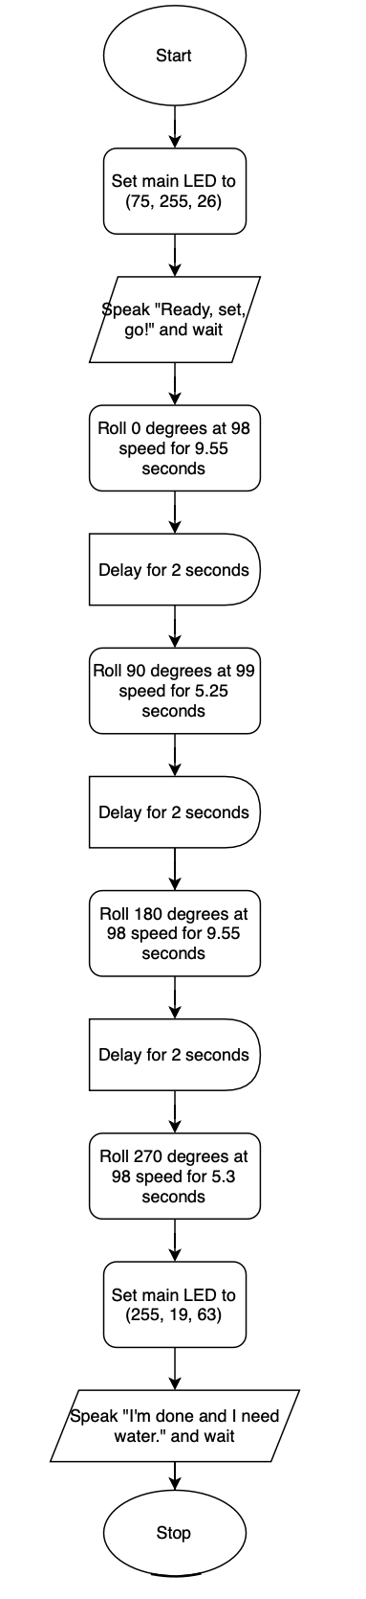

## Software

The Software used for this Robot project was block code in the Sphero Edu application.

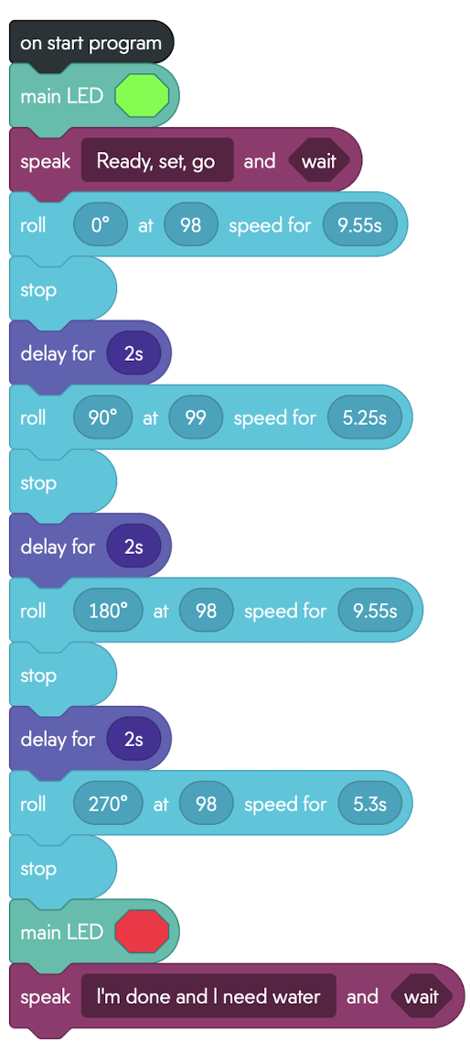

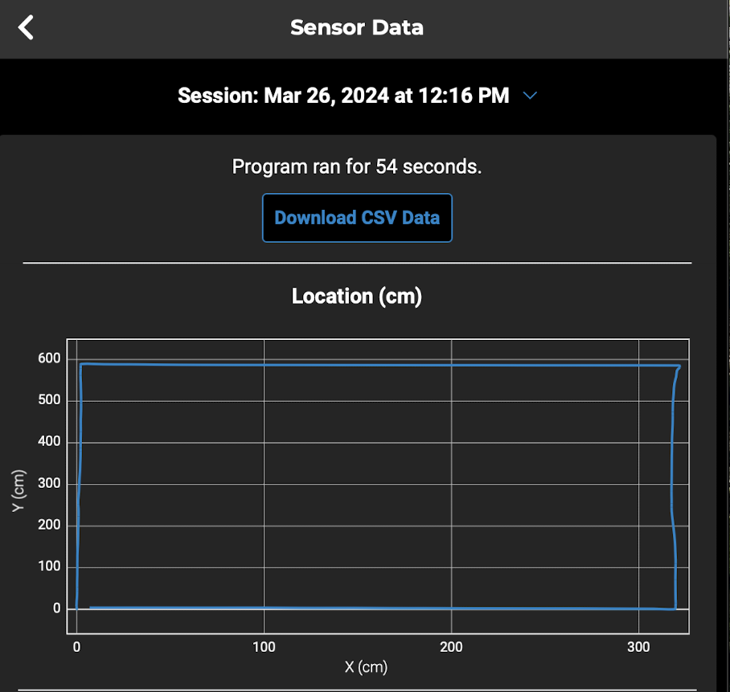

## Hardware

Hardware platforms used:

* Apple MacBook Air
* Windows Surface
* Shepro Bolt

## Test Plan

| **Reason for Test Case** | **Test Date** | **Expected Output** | **Observed Output** | **Staff Name** | **Pass/Fail** |
| --- | --- | --- | --- | --- | --- |
| Test if Main LED light on robot, successfully lights up green. | 03/25/24 | Main LED light turns green. | Main LED light turns green. | Trey, Falvia, Trey | Pass |
| Test if robot speaks “Ready Set Go” successfully. | 03/25/24 | Robot will speak “Ready, Set, Go”. | Robot spoke “Ready Set Go”. | Trey, Flavia, Trey | Pass |
| Test if robot successfully rolls to corner of the track. | 03/25/24 | Robot will travel to the first corner of the rectangle. | Robot traveled to the first corner of the rectangle. | Trey, Flavia, Trey | Pass |
| Test if the robot successfully rolls to the second corner of the track. | 03/25/24 | Robot will turn and travel to the second corner of the rectangle. | Robot turned and traveled to the second corner of the rectangle. | Trey, Flavia, Trey | Pass |
| Test if robot successfully rolls to the third corner of the track. | 03/25/24 | Robot will turn and travel to the third corner of the rectangle. | Robot turned and traveled to the third corner of the rectangle. | Trey, Flavia, Trey | Pass |
| Test if the robot successfully rolls back to the start position. | 03/25/24 | Robot will turn and travel back to the starting position. | Robot turned and traveled back to the starting position. | Trey, Flavia, Trey | Pass |
| Test if Main LED light on robot, successfully lights up red. | 03/25/24 | Main LED light turns red. | Main LED light turns red. | Trey, Flavia, Trey | Pass |
| Test if robot successfully speaks “I’m Done, and I need water.” | 03/25/24 | Robot will speak “I’m done and I need water” | Robot spoke “I’m done and I need water” | Trey, Flavia, Trey | Pass |

## Task List/Gantt Chart

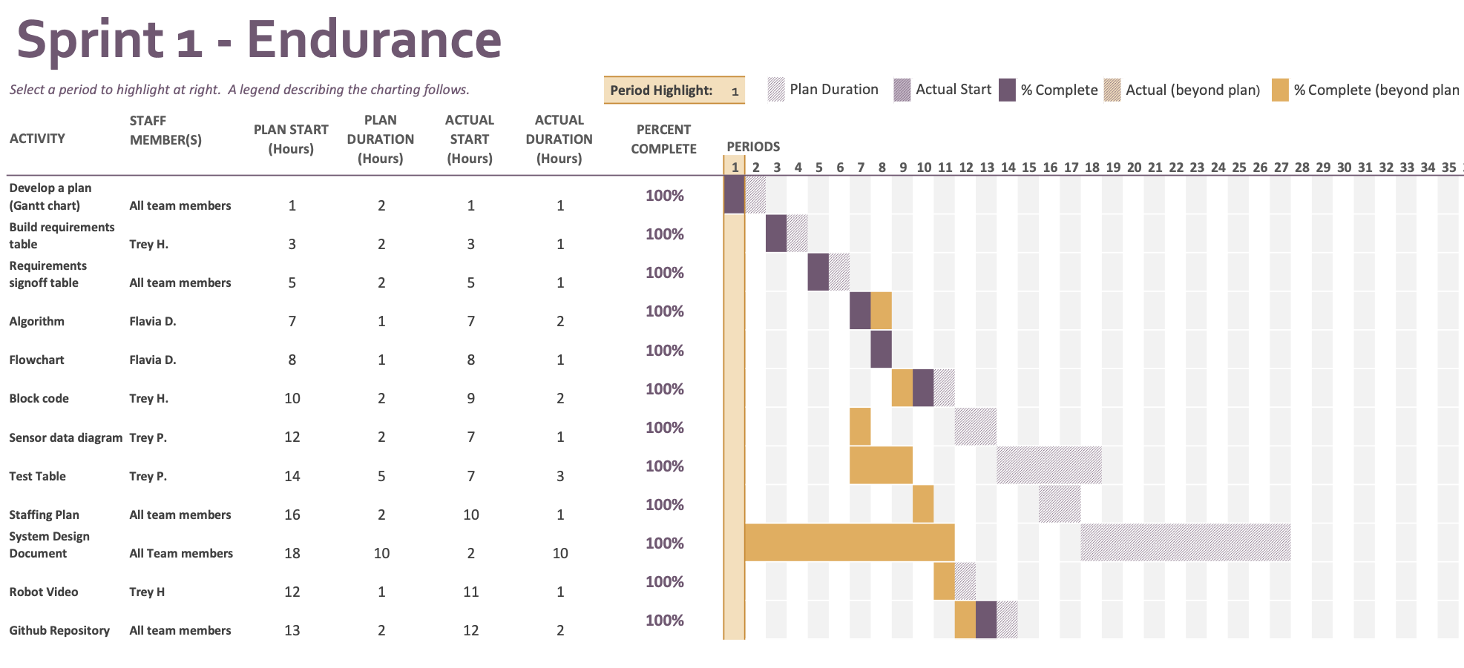

## Staffing Plan

| Name | Role | Responsibility | Reports To |
| --- | --- | --- | --- |
| Trey Harpootlian | Group Member | Algorithm, Robot Video, Planning, Communication with group | Flavia D. and Trey P. |
| Flavia Daniels | Group Member | Flowchart, System Design Paper, Planning, Communication with group | Trey H. and Trey P. |
| Trey Porter | Group Member | GitHub Repository, System Design Paper, Planning, Communication with group | Trey H. and Flavia D. |